**Consultant Payment**

The View Access for raising Consultant Payment is given to those having HR access in DSS and also to those having PM access in DSS.

The PM gets Consultant Payment Creation Access for those projects which he/she has access.

The Consultant Payment behaves differently for various projects.  
The Common Template is discussed here in this document.

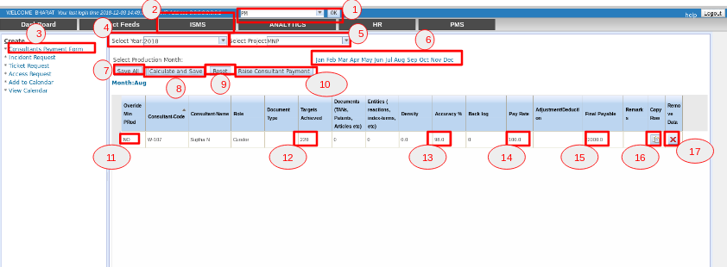

1. Select the role as **PM** (or) **HR** and Click the **OK** button.
2. Select the **ISMS tab**.
3. Click **Consultants Payment Form**.
4. Select the year.
5. Select the Project for which the Consultant Payment is to be raised.
6. Select the Month for which the Consultant Payment is to be raised. The data populates in the grid for that month.
7. **Save All button** - It saves all the data.
8. **Calculate and Save button** - It calculates the final Payable amount and saves the data.
9. **Reset button** - It resets the data back to the initial stages.
10. **Raise Consultant Payment button** - It raises the Consultant Payment , where the approval is done by the Finance.
11. If the Production Numbers were not billed for the previous month because of not achieving the target , those numbers can be added by changing the **Override Min Prod dropdown** to **YES.**
12. The **Target Achieved** gives the total number of Production Numbers to be billed.
13. The **Accuracy** is mentioned for those projects where the Cost is calculated based on the Accuracy.
14. The **Pay Rate** gives the pay predefined for that employee based on the project.
15. The **Final Payable** gives the total cost that is generated to be paid for that employee.
16. **Copy Row** creates a duplicate row.
17. **Delete Row** is used to delete that particular row from the Grid.

The Calculation is unique for all the Projects.

You can connect with the HR Department for queries on the Fee Criteria for the Projects.

If you have any further queries in using the Consultant Payment Feature, You can also contact the DSS SUPPORT ([dsssupport@molecularconnections.com](mailto:dsssupport@molecularconnections.com)).

**For Finance Role:**

Finance can review & approve the request as shown below:

