**Employee Relieving Calendar**

The Employee Relieving Calendar gives the Relieving details of Employees and their current status in the Organisation.

The View access for Employee Calendar is for those having HR role in DSS.

This document gives an overview on the the following functions in the Employee Relieving Calendar.

* Viewing the Exit data of Employees.
* Entering the Exit data in the Calendar.
* Updating the data in the Employee Relieving Calendar.

**Viewing the Exit data of Employees**

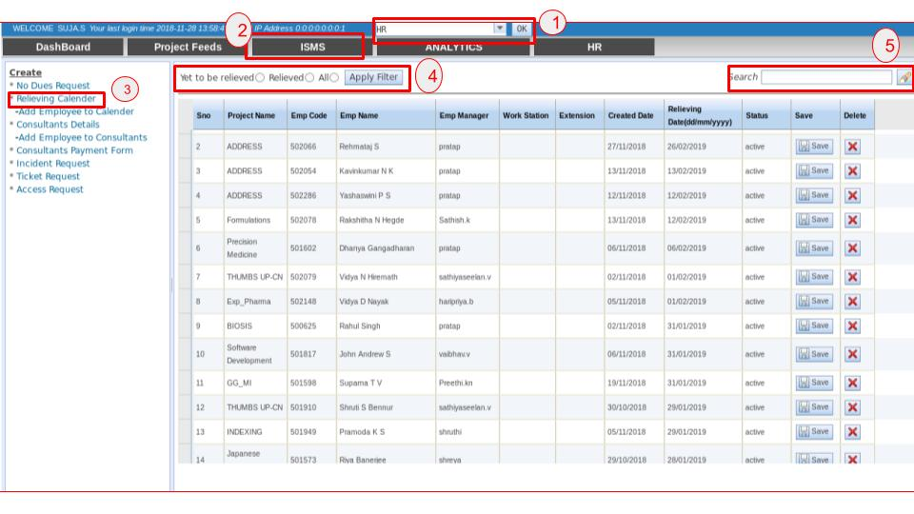

To View the Exit data of the Employees. The following steps are taken

1. Select the role as HR and click the **OK** button next to them.

2. Select the ISMS tab.

3. Select the Relieving Calender in the Left Pane. The Exit data of the Employee appears.

4. The Filters

**Yet to be relieved** - Displays all the employees of active status.

**Relieved** - Displays all the employees of inactive status.

**All** - Displays all the employees in the Exit Relieving Calender.

Select the appropriate radio button corresponding to the required filter and Click **Apply Filter** button.

The dataset for the applied dataset populates.

5. The Search operation can be performed based on the **Employee Code** or the **Employee Name**.

**Entering the Exit data in the Employee Relieving Calendar**

The data in the Employee Relieving Calendar can be added by two ways.

1. By Adding the Employee to the Relieving Calendar directly.
2. By Creating an Exit & Resignation Request.
3. **By Adding the Employee to the Relieving Calendar directly**

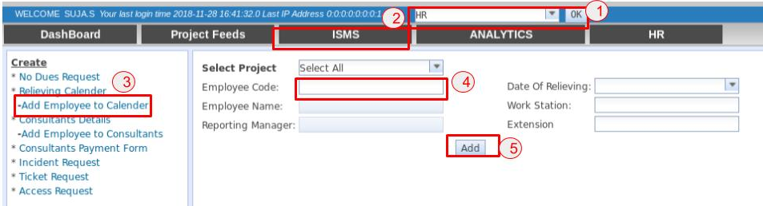

To Add the Exit data of the Employees. The following steps are taken

1. Select the role as HR and click the **OK** button next to them.
2. Select the ISMS tab.
3. Select the **Add Employee to Calender** in the Left Pane. The Add Exit Relieving Employe Form appears.
4. Enter the Employee Code and click outside the Employee Code field, the Employee Name gets populated automatically.
5. Click on the **Add** button to insert an Employee record to Employee Relieving Calender.

**2. By Creating an Exit & Resignation Request**

At the time of Creation of an Exit & Resignation by the respective Reporting Manager. An employee record is created automatically in the Employee Relieving Calender.

**Updating the data in the Employee Relieving Calendar**

The data in the Employee Relieving Calendar can be updated by one of the following ways.

1. By Editing in the Employee Relieving Calendar.
2. By Updating in the Exit & Resignation Request.
3. By Updating the values at the time of No-Dues Creation.

**3. By Editing in the Employee Relieving Calendar**

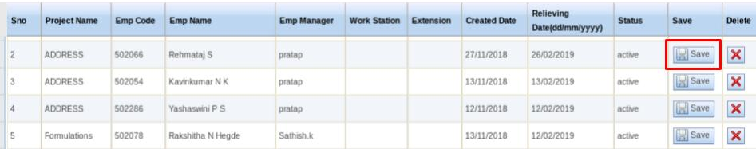

The Relieving Date and the Status of an Employee can be updated by this method.

Double click on the respective Relieving date or the Status that needs to be updated and Click on the **Save** button to update the employee’s data.  
The Relieving date gets updated both in the Exit Relieving Calender and also in the Exit & Resignation Request Form.

**4. By Updating in the Exit & Resignation Request**

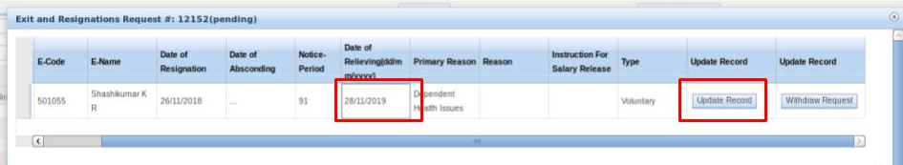

Updation of the Relieving Date of an Employee involves the following

1. Open the respective Exit and Resignation Request from the DashBoard.
2. Double Click on the Date of Relieving Field to update the values.
3. Click on the **Update Record** button to update the values.

The View and the Modification access is given to all those having Full Access for that Project (Mostly the PMs) and those having HR role in DSS.

**5. By Updating the values at the time of No-Dues Creation**

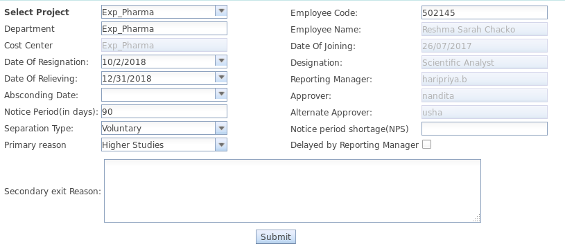

At the time of creation of No-dues by the HR, the Relieving Date of that particular employee in the Employee Relieving Calendar gets updated to that of the date in which the No-Dues is created.

**For example :**

If the Relieving date of an employee in the Employee Relieving calendar is 12/31/2018.

But the No-Dues was created on 12/20/2018.

Then the Relieving date of that employee gets updated as 12/20/2018.