**EMPLOYEE PIP (PERFORMANCE IMPROVEMENT PLAN) MODULE**

**Brief Introduction:**

The PIP module would form an integral part of PMS process wherein any Manager with team responsibilities can help the underperformers in her/his team and come up with a specific time bound performance improvement plan tailored to each individual member’s improvement needs to help them in meeting the expected standards and support them in achieving the desired results. Manager can keep track of the team member’s progress by reviewing at regular intervals and can also plan new interventions and keep a record of such efforts and the outcome/results using the PIP module. This enables the employee to get an opportunity to receive special attention & training to focus on improvement areas. Managers can also evolve a systematic way of handling performance issues in the team and strengthen the process of identifying the gaps and upgrade their training & development framework. Managers can decide to either extend the PIP session further or conclude it for an employee under review at the end of each review session.

It is extremely important not to stigmatize the members undergoing PIP by showing empathy and providing lots of support and encouragement to help them achieve the desired results.

**Step 1: Initiation**

Performance Improvement Plan tab is available in the Project Feeds of all Reviewing Managers

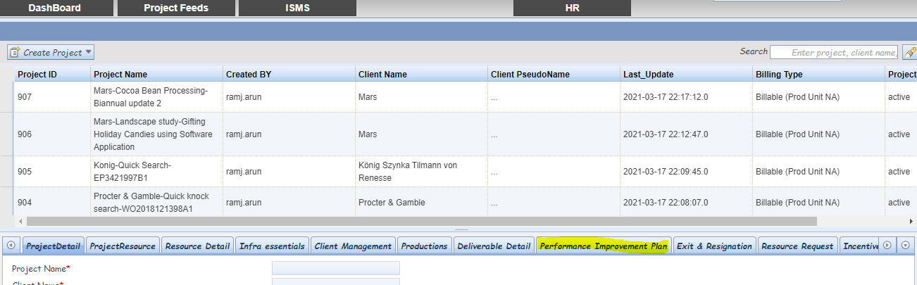

**Step 2: Creating a PIP Session**

Managers can open a PIP session for an employee who needs to undergo PIP process by first selecting the parent project of the employee and then adding the member’s details.

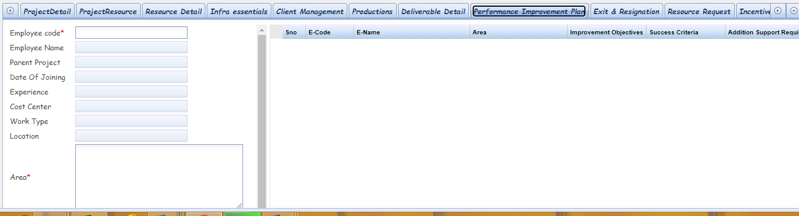

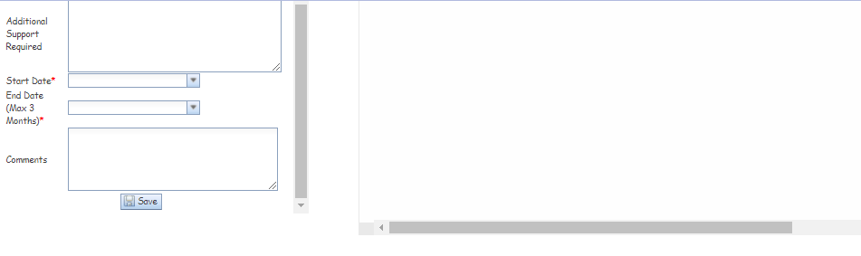

**Step 3: History**

Once an employee is added to the PIP module, their details would be available both in the dashboard as well as *Project Feeds* tab

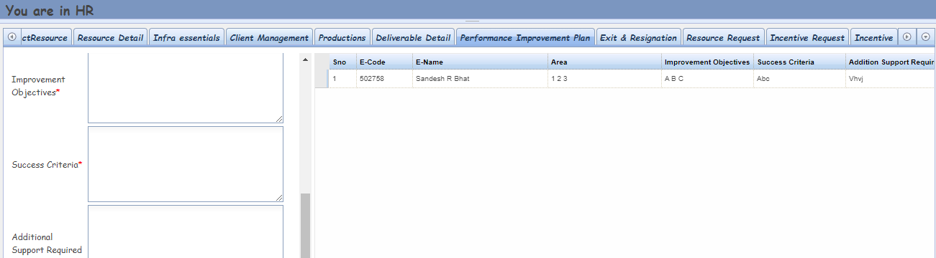

**Step 4: Dashboard**

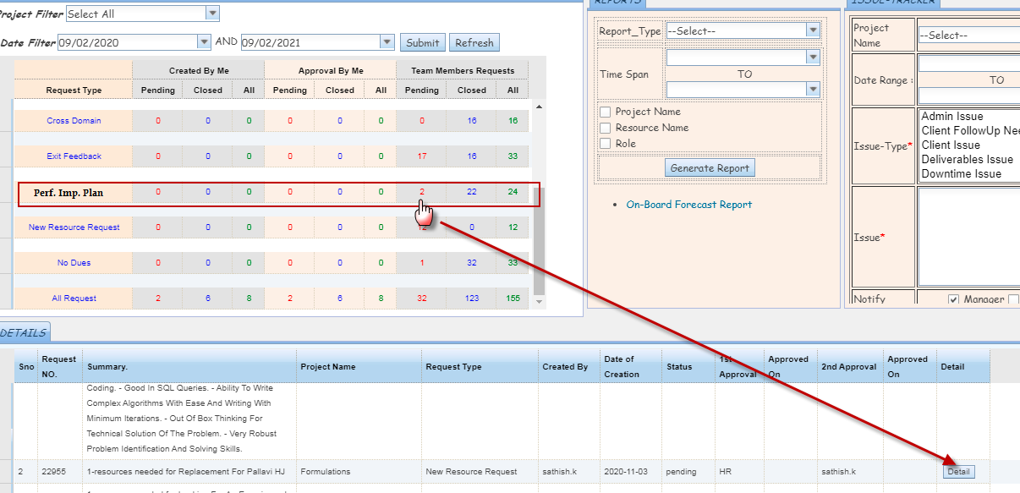

**Step 5: Progress Review & Update Form**

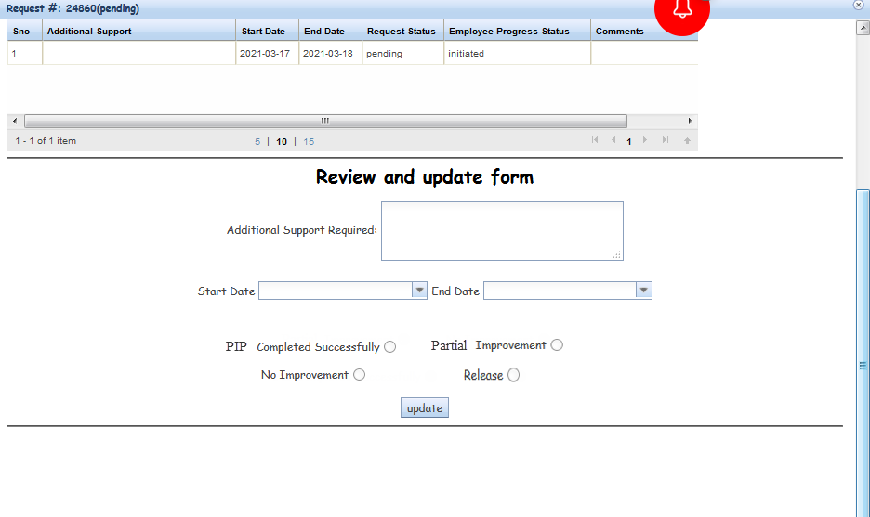

**Step 6: Employee Status Update**

* **PIP Completed Successfully:** Shown significant improvement in all areas and met the expected standards – ‘To be moved out of PIP and not to continue/extend the PIP’
* **Partial Improvement:** Observed significant improvement in few areas but yet to meet the expected standards – ‘ PIP to be continued/extended’
* **No Improvement**: Not shown significant improvement and not met the expected standards during the review period, but can be counseled on performance – ‘PIP to be continued/extended’
* **Release:** Not shown required improvement and did not meet the expected standards even after regular performance counseling at the end of each review period – ‘Can be considered for any other assignments OR can be relieved’

**Please Note:**

Once the employee PIP status is marked as “Completed Successfully” or “Release”, then the PIP session for that particular employee shall be closed. The history of all PIP sessions shall be accessible to the Managers as well as HoDs.