**Exit Feedback**

The Exit Feedbacks are collected at the time of the exit of the employees. It is done only if the No-Dues is raised as an Non-Absconding Employee.

The View Access for Exit Feedbacks are given to those having Full Access to the DSS project on which the No-Dues was raised ( Mostly the Project Managers ) and those having HR role in DSS.

The Exit Feedback involves the following process.

* Creation of the Exit Feedback.
* Feedback Submission by the Employee.
* Feedback Submission by the PM.
* Feedback Submission & Closure by HR.

**Creation of the Exit Feedback**

The Exit Feedback is created Automatically at the time of No-Dues Creation by the HR, for the Non-Absconding Relieving Employees.

**Feedback Submission by the Employee**

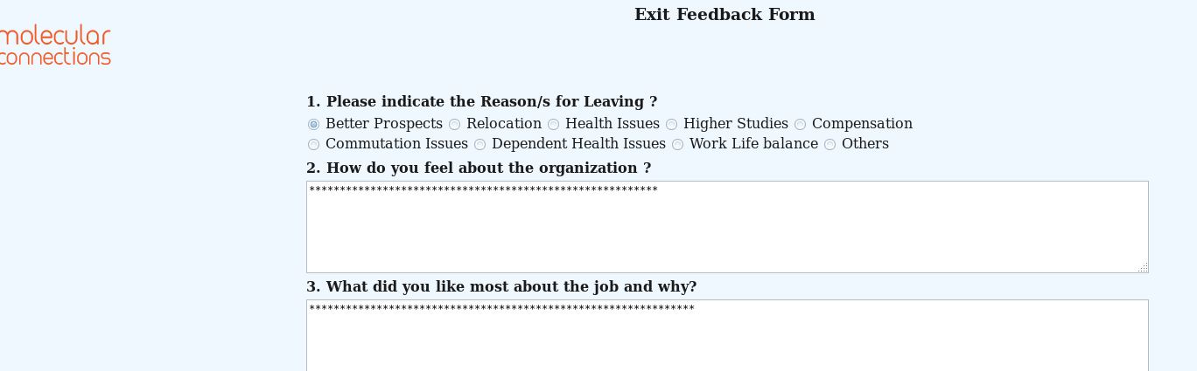

* A Notification mail is sent to the Exit Employees and those having HR role in DSS containing the URL for filling the Exit Feedback Form.
* The Employee completes the Form and Submits them.
* If the Employee wants to update any details, the HR will be able to update them before the closure of the request. (As the feedbacks cannot be modified by the Exit Employees.)

**Feedback Submission by the PM**

The Feedback Submission by the PM is an optional field.

It can be done only by the person who is marked as the Creator of the DSS project on which the Exit Feedback is raised.

And can only be submitted before the Closure of the Exit Feedback request by the HR.

**For Example**:  
 If a No-Dues is raised for an Employee under **Syntrans whose creator is swathi.s**

Then the Exit Feedback that got generated for that employee can only be **submitted by swathi.s**

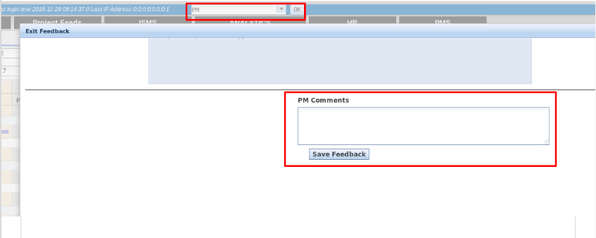

To submit the feedback the following steps are followed.

* Select the **PM** role in DSS.
* Click on the Dashboard tab and select the Exit Feedback Request that is there in the pending status.
* Select the **Details** button on the grid for the employee that needs to be updated.
* Enter the PM Feedbacks and Click **Save Feedback** button.

**Feedback Submission & Closure by HR**

The Exit Feedbacks can only be closed by those having HR role in DSS.

At the time of HR Feedback Submission, the Exit Feedback Closure is done.

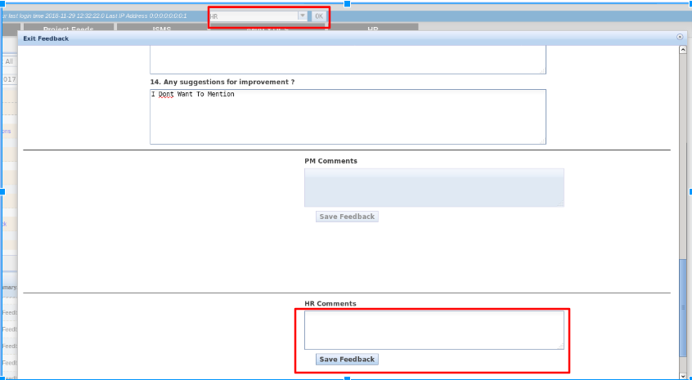

To submit the HR feedbacks and to close the request, the following steps are followed.

* Select the **HR** role in DSS.
* Click on the Dashboard tab and select the Exit Feedback Request that is there in the pending status.
* Select the **Details** button on the grid for the employee that needs to be updated.
* Enter the PM Feedbacks and Click **Save Feedback** button.