**Offsite Consultant Payment**

**For Finance Role:**

Finance can review & approve the request as shown below:

Do the following steps for Offsite Payment Approval

1. Select the role as **Finance** and Click the **OK** button
2. Click on the **Consultant Payment Request**.
3. Click on **Details** button to review and approve the payment request.
4. Click on **Approve Consultant Payment** button, to approve the selected Incentive request.

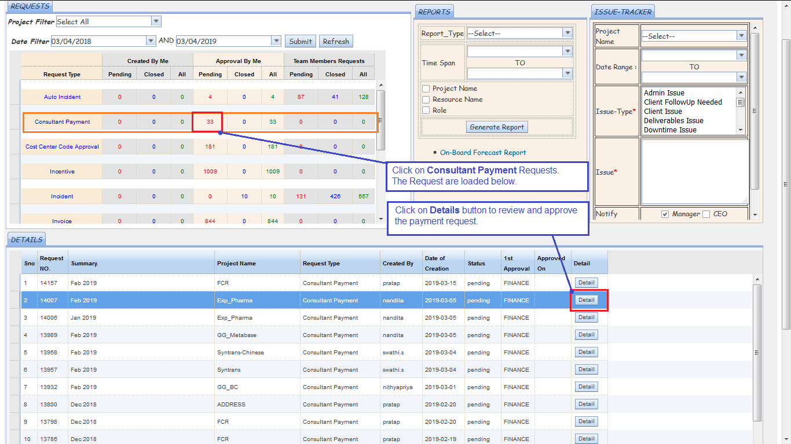

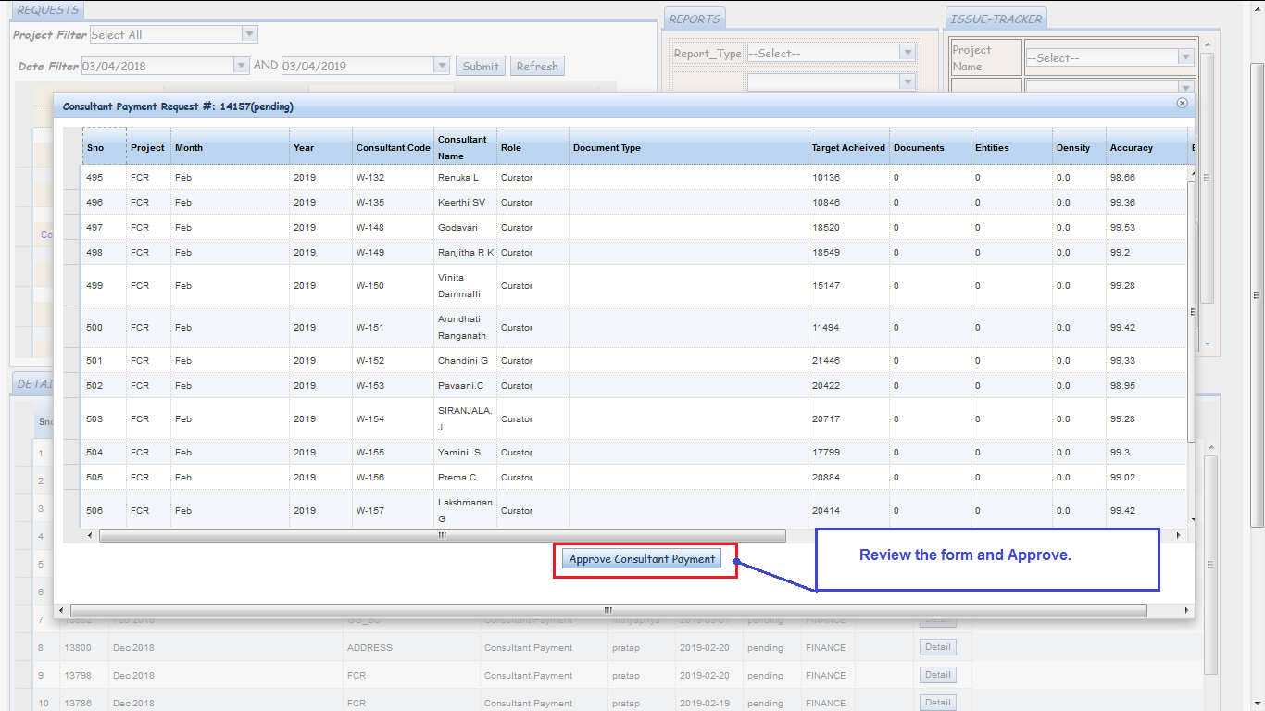

**Incentive Approval by Finance**

The Incentives can be created based on the Projects in DSS.

It can be raised only for a particular project in one request.  
ie., For an employee if an Incentive is to be raised for two different projects, then two seperate requests needs to be placed.

The Incentive process involves the following steps

* Incentive Template Creation
* Incentive Generation by PM
* Incentive Approval by Finance

The Incentives can be approved by those having **Finance role** in DSS.

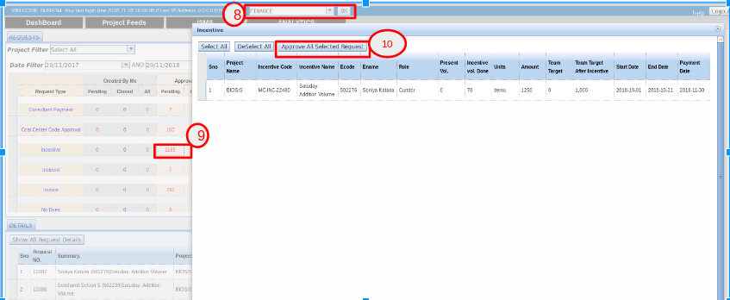

Do the following steps for Incentive Approval.

1. Select the role as **Finance** and Click the **OK** button
2. Click on the Pending Incentives.
3. Click on **Approve All Selected Request** button, to approve the selected Incentive request.