**Incentives**

The Incentives can be created based on the Projects in DSS.

It can be raised only for a particular project in one request.  
ie., For an employee if an Incentive is to be raised for two different projects, then two seperate requests needs to be placed.

The Incentive process involves the following steps

* Incentive Template Creation
* Incentive Generation by PM
* Incentive Approval by Finance

**Incentive Template Creation**

Incentive Template Creation for a project is a one time request.

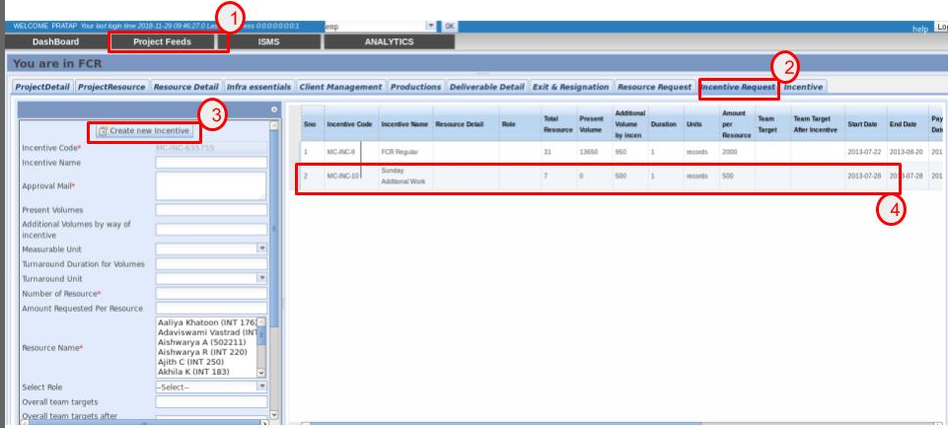

To create an Incentive Template, do the following steps

1. Select the project for which the Incentive Template is to be created, by selecting **Project Feeds** tab.
2. Select the **Incentive Request** Tab to populate the Incentive Template Creation Form.
3. Click on Create new Incentive button, which generates a unique Incentive Code. Enter all the mandatory details and select **Save** button (which appears at the creation of Incentive Code).
4. Once the Incentive Template is created, they appear in the grid which is placed in the Right Pane.

**Incentive Generation by PM**

The Incentives are generated with the help of Incentive Template.

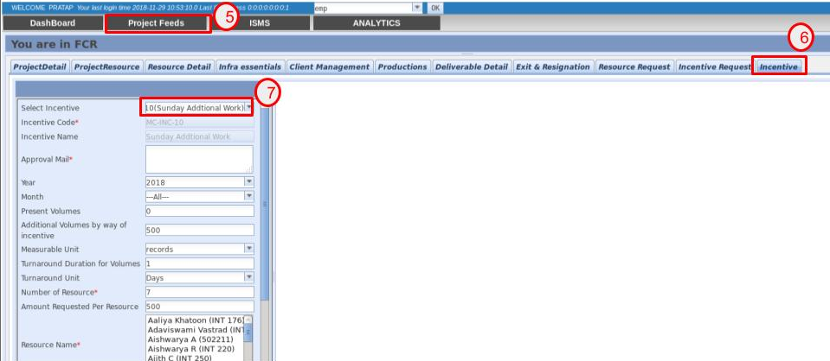

To create an Incentive , do the following steps

1. Select the project for which the Incentive Template is to be created, by selecting **Project Feeds** tab.
2. Select the **Incentive** Tab to populate the Incentive Template Creation Form.
3. Select from the **Select Incentive** drop down, to Auto-Populate the fields . After the updation of data , click **Add Resource For Incentive** button to raise the Incentives.

The Incentive details can be viewed in the Dashboard under Incentives.

**Incentive Approval by Finance**

The Incentives can be approved by those having **Finance role** in DSS.

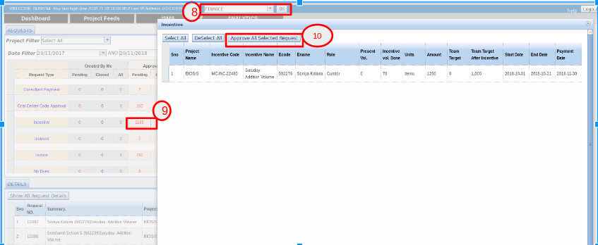

Do the following steps for Incentive Approval

1. Select the role as **Finance** and Click the **OK** button
2. Click on the Pending Incentives.
3. Click on **Approve All Selected Request** button, to approve the selected Incentive request.