**No-Dues Process**

The No-Dues process involves the following steps.

* Relieving Date Remainder.
* Relieving Calendar.
* No-Dues Creation by HR.
* Addressing the No-Dues.
* No-Dues Closure.
* Auto-Incidents based on Late No-Dues.

**Relieving Date Remainder**

The No-Dues process is initiated by the relieving employee’s Reporting manager. The Reporting Manager informs the HR to initiate the process.

The Reporting Manager and those having HR Role in DSS gets the Remainder Mail about the Exit of an Employee on the day of the employee’s exit and two days prior to the employee’s exit.

The Employee’s exit is recorded in DSS at the time of creation of the Exit and Resignation.

**Relieving Calendar**

The View Access for Relieving Calendar is for those having HR role in DSS.

The Relieving Calendar is placed inside the ISMS tab.

The Relieving Calendar gives the information on the Relieving details of the Employees.

Here various operations like Updation of Relieving Date and Status can be performed.  
To Update, Double Click on the Cell in the Row which contains the Employee Detail, that needs to be updated and click the SAVE button that is available on each corresponding Employee detail row.

**No-Dues Creation By HR**

The No-Dues process is initiated by the relieving employee’s Reporting manager. The Reporting Manager informs the HR to initiate the process.

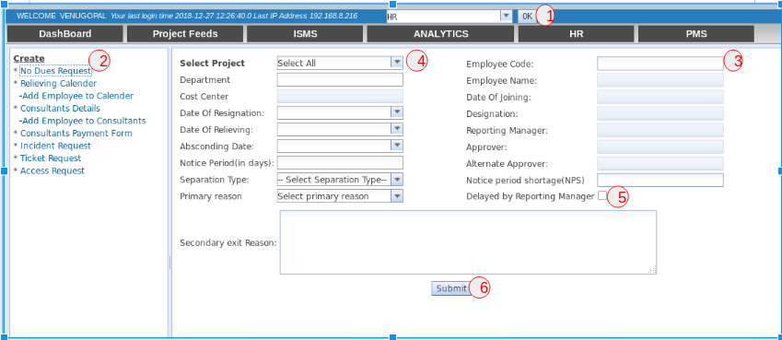

The HR initiates the process by performing the following steps in DSS.

1. Select the DSS role as **HR** and Click on the **OK** **button**.
2. Select the **No-Dues Request** Link in the Left Pane, to open the No-Dues Creation Form.
3. Once the **Employee Code** is entered, the data are auto-populated in many fields. If the No-Dues was already been raised of that Employee Code, an alert message is displayed.
4. Select the **Project**, it Auto-Populates the No-Dues Approver and Alternate No-Dues Approver.
5. The **Delayed by Reporting Manager checkbox** is used, if the Reporting Manager had not informed the HR to raise the No-Dues on time.
6. Click on the **Submit button** to create an No-Dues Request.

**Addressing the No-Dues**

The No-Dues process involves various steps. Addressing the No-Dues after its Creation can be broadly classified as follows:

* Addressing the No-Dues by Reporting / Project Manager.
* Addressing the No-Dues by IT, Admin, Accounts, HR.

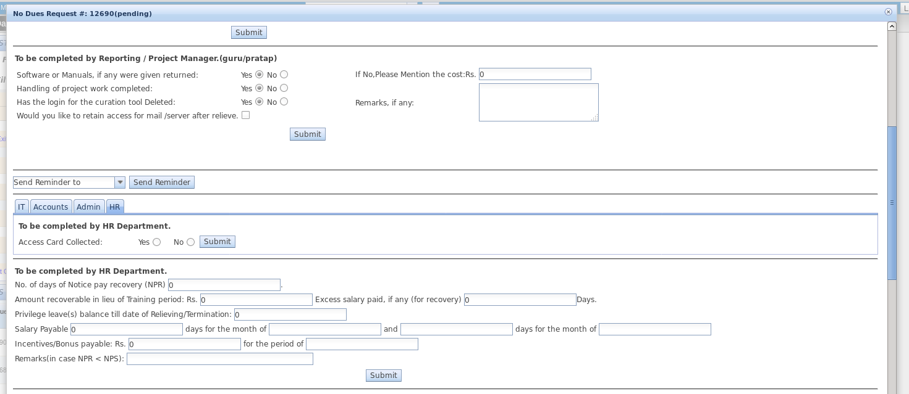

**Addressing the No-Dues by Reporting / Project Manager**

The No-Dues can be addressed by the Reporting / Project Manager who are mentioned in the DSS project, under which the No-Dues are created.

**For Example :**   
 If an employee who works under FCR project and the No-Dues is raised under Address project, then the Reporting / Project Manager of Address project can only clear that employees No-Dues.

It cannot be cleared by the Reporting / Project Manager of FCR project.

**Addressing the No-Dues by IT, Admin, Accounts, HR**

The No-Dues are cleared Simultaneously by all these departments (Admin, Finance, HR, SYSOP). But the Process is enabled only after the RM / PM clears the No-Dues.

**Closure of Incidents by Finance** The Closure of No-Dues happens after the Final Settlement is processed and the Accounts team marks them in DSS.  
The operation is performed by selecting the **Final Settlement Processed checkbox** and clicking on the **Submit button**.

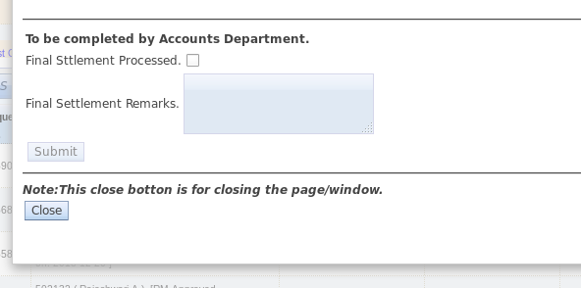

**Auto-Incidents based on Late No-Dues**

The Auto-Incidents are generated automatically by the HRMS System, if the No-Dues are not created on time.

The Time Frame for the creation and the submission of the clearances of No-Dues are indicated below for the respective departments:

HR : by 4pm

Reporting Manager : by 5pm

IT Department : by 7pm

Finance Department : by 7pm

Admin Department : by 7pm