**Production**

The Production Numbers can be logged for a project in DSS. They can be used for various purposes like for generating Invoices , Production Report , Costing Report , ….

The Production Entry Process in DSS includes two process.

* Entering Production Numbers for the Entire Project.
* Entering Production Numbers for Individuals within a Project.

**Entering Production Numbers for the Entire Project**

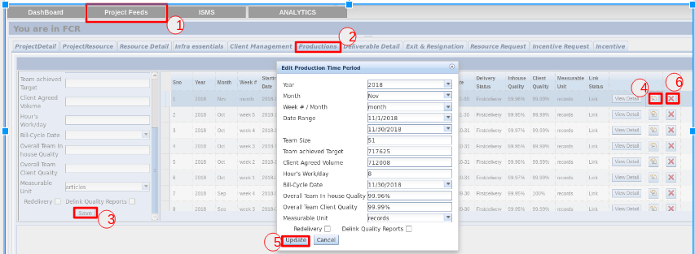

The Following steps are followed to enter the Production Numbers for the entire project

1. Go to **Project Feeds** and select the Project for which the Production Numbers needs to be entered.
2. Select **Productions** **Tab**.
3. In the Left Pane, fill the details and click the **Save** **button**. The Newly created data appears in the Right Pane.
4. If a particular data needs to be updated, the **update icon** is selected. It opens a dialog box, which contains all the details.
5. The **Update** **button** in the Edit Production Dialog box is used to update the data.
6. The **Delete** **Icon** is used to remove the unwanted data records.

**Entering Production Numbers for Individuals within a Project**

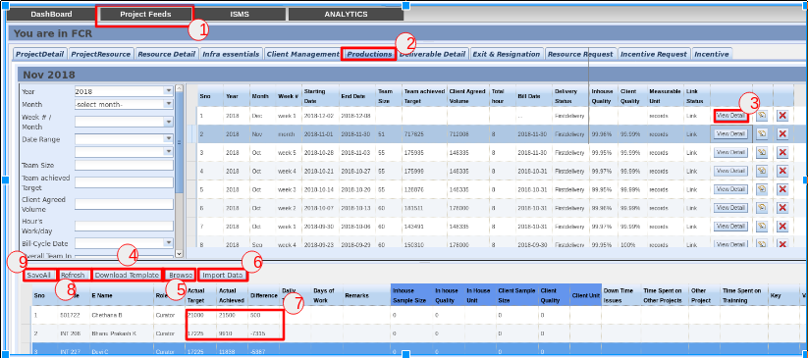

The Following steps are followed to enter the Production Numbers for each individuals in a project for a specific period.

1. Go to **Project Feeds** and select the Project for which the Production Numbers needs to be entered.
2. Select the **Productions Tab**.
3. Select the **View Detail button**, to get the Individual Production details of the Employees.
4. The **Download Template** button is used to generate an Excel File with the Employee Data of the Project for that specific period. The Production Data are updated in the Excel File.
5. The **Browse button** is used to select the Excel File to be imported into the DSS System.
6. The **Import Data** button imports the Production Data. If there is any inconsistency in the Data, an alert message appears and the data won’t be imported.
7. The data can also be updated by double clicking on the fields in the grid, and updating the data value.
8. The **Refresh button** is used to refresh the data in the grid. It restores the data that was existing at the time of Saving the data.
9. The **SavaAll button** is used to save the Production data.